Summary of docking methods for YhcB

No structure is known for *E. coli* YhcB, therefore, the structure used to dock YhcB was a structure of a homolog of the protein found in *Haemophilus ducreyi*,which is referred to as HDR25. HDR25 is 21% sequence identical to *E.coli* YhcB, and 42% sequence-similar (counting identical and same-residues-group substitutions). HDR25 is a tetramer, however, YhcB in *E. coli* was not found to self-associate in yeast two-hybrid screens. Therefore, a monomeric structure for YhcB was generated by taking a single chain (A) from the YhcB tetrameric structure in *H. ducreyi*. For all dockings, YhcB tetramer as well as monomer were used and the results were combined to best inform inferences about the actual conformation of binding between YhcB and partners. As indicated earlier, YhcB was found to interact with the cell divisome and elongasome proteins FtsI, FtsQ, RodZ and RodA, in *E. coli*, and MreB and FtsZ in *Yersinia pestis*, additionally. Of these interaction partners, structures could be found for FtsI, FtsQ, and MreB. The structures used for FtsI and FtsQ were 4BJP and 2VH1, respectively. 4BJP is a single-chain structure, however, FtsQ is a dimer. A monomeric structure for FtsQ was generated by taking a single chain from 2VH1. HDR25 monomer and HDR25 tetramer were docked to FtsI monomer, FtsQ monomer, and FtsQ dimer. For FtsZ, homologous structures were available with high sequence identity (e.g. 1OFU from *Pseudomonas aeruginosa*, 68% sequence identity), however, these structures were only partial and may lack regions critical for interaction. For MreB, 4CZL was used, which is a structure of *Caulobacter crescentus* MreB (61% sequence identity over 97% of the sequence length).

**Table 1 Docking experiments performed**

|  |  |  |  |  |  |  |  |
| --- | --- | --- | --- | --- | --- | --- | --- |
|  | FtsI (4BJP:A) | FtsQ monomer (2VH1:A) | FtsQ dimer (2VH1:A-B) | RodZ | RodA | MreB (4CZL:A) | FtsZ (1OFU:A) |
| YhcB monomer (HDR25:A) | + | + | + | - | - | + | - |
| YhcB tetramer (HDR25:A-D) | + | + | + | - | - | + | - |
|  |  |  |  |  |  |  |  |
|  |  |  |  |  |  |  |  |

HDR25 vs E. coli YhcB

As indicated above, HDR25 is 21% sequence identical to *E.coli* YhcB, and 42% sequence-similar. Although conservation information for YhcB across multiple species is already provided (ConsurfDB profile), it is important to note that nearly all of the known and suspect important residues in YhcB *E. coli* are conserved (identical or similar) in HDR25. This includes the His-Phe patch (61, 62, 65, 82, 83) and adjacent residues (86, 87) except for 90, as well as hypothetical interactor residues (69, 76, 80) though not 68 and 75, and suspected transmembrane residues (37, 44).

YhcB variants

The five variants cover different stretches of YhcB sequence, in ascending order from V1 (most N-terminal) to V6 (most C-temrinal), with V7 the exception (N-terminal 1-21 deletion). Only V3 has a mutated residue (L62A) in the His-Phe patch or neighboring residues, while V4 has a mutated residue in the suspected interactor residues (D69A), and V5 has two mutated residues among the suspected interactor residues (H76A and S80A). Interestingly, only V1, V4, and V5 lose interaction with any partner proteins. Equally interesting is that V5 loses interaction with the most partners: FtsI, RodZ, and YidC. Because of the apparently greater disruption to YhcB binding in general, and because docking was possible with FtsI but none of the other partners affected by V1 and V4, V5 and the YhcB+FtsI interaction was the focus of docking experiments. Also, V5 contains mutations in residues 76 and 80, which were found to be invariant in all sequences used for the ConsurfDB calculation.

Docking results

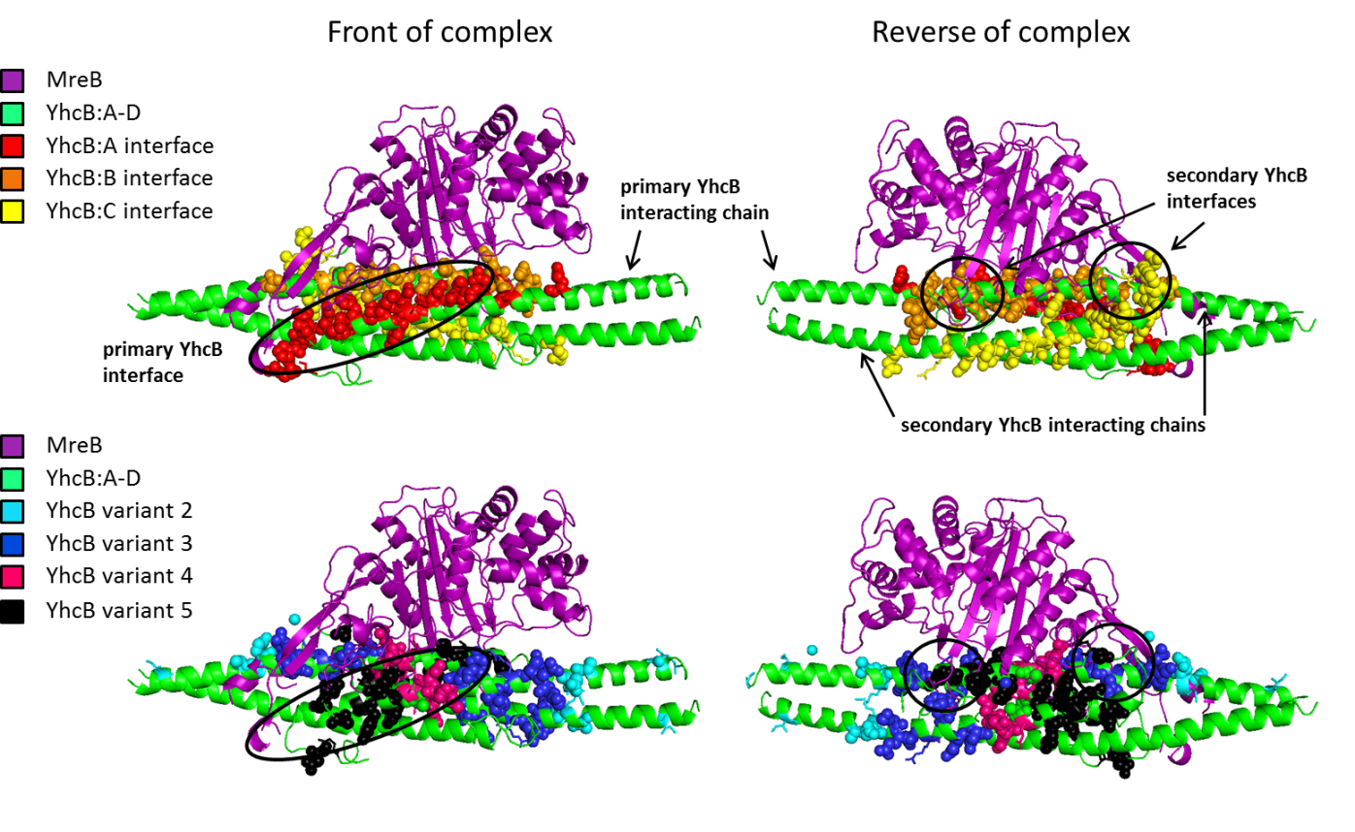

**Figure 1 Yhcb-MreB complex.** The predicted structure of YhcB in complex with its partner, MreB, in *E. coli* is shown. MreB was docked to a single chain (A) of the YhcB tetramer, and the primary interaction interface (top left, red) is shown. This interface contains variants 4 and 5, as well as a portion of variant 3 (bottom left, black oval). Possible secondary interaction interfaces with additional chains of YhcB (top right, orange and yellow) are also present. These secondary interfaces contain variants 3 and 5 (bottom right, black rings). *Note:* variant 3 in the YhcB chain A is not involved in the secondary interface (bottom right, left black ring), therefore variant 5 is the dominant variant overlapping the secondary interfaces.